****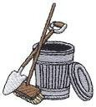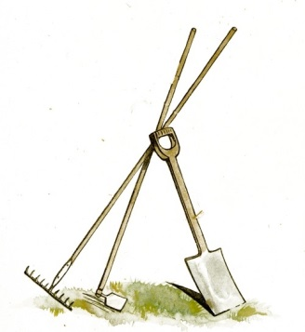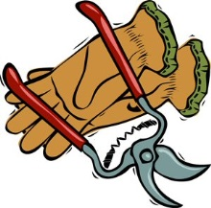

## Saturday, June 6, 2015

**Start 8:30 a.m. *till* 12:00 p.m.**

**Any Questions?**

**Call the Mayor @ 541-306-0159 or email:** [**kmulenex@ci.la-pine.or.us**](mailto:kmulenex@ci.la-pine.or.us)

**GREAT NEWS**

**“Let’s Pull Together”**

**Joins La Pine City Clean-up Day for Noxious Weed Eradication Day,**

***Saturday, June 6, 2015*.**

**Yes, that’s right! We decided to attack both problems, City Clean-up and noxious weed eradication on the same day.**

**At 12:30 p.m. we’ll meet back at Community Center for a great BBQ!!**

*Our Famous “American Legion Honor Guard” will be our BBQ Chefs for the event*

This is a GREAT

OPPORTUNITY

to make La Pine

shine!

We’ll meet at

“La Pine Community Center” at

8:30 a.m., form

up crews, get assignments, plenty of instructions and directions.

**Please dig out your “GLOVES”, Rakes, Hoes, Clippers, Push-brooms, Shovels, Weed-eaters,**

**Wheelbarrows, etc.**

**We will provide the**

**BIG YELLOW Trash Bags**

**for your YARD debris!**

La Pine City Clean-up Day